GRANT APPLICATION FORM

- Applicant Name(s) ________________________________________________________________________
___________________________________________________________________________________________
Applicants can be teachers, staff, parents or students. Students must have a teacher or staff sponsor.
2. Primary Contact Information ________________________________________________________________
Please provide email address of at least one Applicant.
3. Project Name ____________________________________________________________________________
4. Grade Level(s) participating ___________ 5. # of Students participating _________
6. Project Description _______________________________________________________________________
___________________________________________________________________________________________
___________________________________________________________________________________________
___________________________________________________________________________________________
___________________________________________________________________________________________
Attach any information (brochures, website information etc.) that helps describe your project and any specific items to be purchased. The Foundation is more likely to fund projects that are consistent with its mission (see below), that impact many students and relate to the following: STEM, Art & Cultural Enrichment, Early Literacy and 360 Wellness (including athletics).
7. Total Amount Requested $___________
Also attach a detailed breakout of all project costs associated with the project. Projects cannot be funded without a detailed breakout of costs. The Foundation may not be able to fund projects that exceed $5,000.
8. How does your project fit in with District curriculum? ____________________________________________
___________________________________________________________________________________________
___________________________________________________________________________________________
9. How is your project consistent with the Foundation’s mission? _____________________________________
___________________________________________________________________________________________
__________________________________________________________________________________________________________________________

10. Name and email of person responsible for Grant Feedback? ______________________________________
___________________________________________________________________________________________
If your grant request is for >$500, the name and email address of the person responsible for completing the Grant Feedback form located on the Foundation website must be provided. The Foundation may, at its discretion, request feedback from the Applicant for grants for <$500.
11. Applicant Signature ________________________________________ Date _______________
12. Signature of Principal (or Superintendent) ________________________________ Date _______________

Completed grant applications should be submitted to Shelly Colley in the Foundation office or via email at foundation@tufsd.org. Shelly can be reached at (914) 366-8457 if you have any questions regarding your application. Applications are due by the last day before the Thanksgiving break, and you should expect to hear whether your project has been approved by the second week in January.
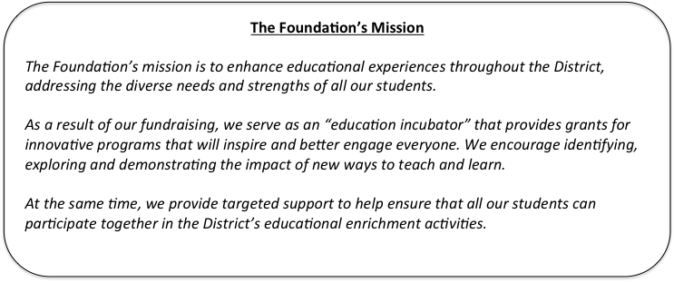

Foundation Use Only:
- 360 Wellness
- Art & Cultural Enrichment
- Early Literacy
- STEM
- Other ____________________________________

